Michigan State University

Department of Chemistry

**Two- and Three- Gamma Positron Annihilation Imaging Using a Gamma-Ray Tracking Detector**

Author:

Nicolas Danato Dronchi

September 10, 2018

Advisors:

Gregory W. Severin

Michigan State University

Department of Chemistry

Facility for Rare Isotope Beams

Dirk Weisshaar

National Superconducting Cyclotron Laboratory

Table of Contents

Abstract 3

Introduction 3

Methods 6

Data Collection 6

22Na Sealed Source Imaging 6

microPET Phantom Imaging 7

Data Reduction 8

Two- Gamma data 8

Three- Gamma data 9

Three- Gamma control data 9

Reconstructions 10

Two-Gamma Reconstructions 10

Three Gamma Triangulation 11

Simulations 13

Results 13

Two Gamma Reconstructions 13

Three Gamma Reconstructions 19

Discussion 24

Conclusion 27

Acknowledgements, References, Supplemental 28

Appendix- Three Gamma Triangulation algorithm 29

1) Finding the Angles Between the Photons 30

2) Find the Third Point 31

3) Translation and Change of Basis 31

4) Equations of the Circles 32

5) Solve for the Intersection of the Circles 32

6) Inverse Basis Change and Translation 33

# Abstract

The GRETINA detector assembly, a high purity germanium gamma-ray tracking array, is a state-of-the-art device for performing coincident gamma-ray measurements in nuclear structure experiments. In some of its configurations, the array can also be used as a nuclear imaging device with gamma ray energy resolution on the order of 2 keV at 511 keV. During a GRETINA campaign at Michigan State University, the characteristics of nuclear imaging with GRETINA were investigated by tracking photons from both two- and three- photon positronium-annihilation events originating from sodium-22 and fluorine-18 phantoms. Two-gamma tomographs were generated in two- and three-dimensions using filtered and unfiltered back-projection reconstruction algorithms respectively. A centered 6 mm diameter sodium-22 source reconstructed in two-dimensions resulted in FWHMs of 7.40 mm, 6.00 mm, and 4.14 mm in the x, y, and z directions respectively. The same source reconstructed in three-dimensions resulted in FWHMs of 10.17 mm, 6.85 mm, and 5.75 mm along the direction of maximum variance, perpendicular to the maximum variance, and axial to the detector opening respectively. For the three-gamma imaging, decays from a thin film sodium-22 source with diameter 10 mm were reconstructed via triangulation resulting in FWHMs of 15.92 mm, 19.07 mm, and 13.23 mm in the array’s nominal x, y, and z directions respectfully. Monte Carlo simulations were used to benchmark the reconstructions, and to interpret the factors impacting the image resolution.

# Introduction

Positron-emission tomography (PET) is a valuable technique in nuclear medicine. In clinical practice it is used primarily for detecting and observing metabolic processes linked to cancer. More generally, PET provides physicians a tool to noninvasively determine the chemical and biochemical nature of lesions without resorting to biopsy. There are many areas of active research to improve PET such as in designing more-specific radiopharmaceuticals, advancing reconstruction algorithms, and developing additional radioisotopes for use in tracers [1]–[3]. Further, new detector technologies are constantly being integrated into PET scanners in order to improve image resolution and quantitation by reducing response time, increasing sensitivity, and increasing interaction-point precision.

Traditional PET imaging requires a ring of detectors in order to intercept and detect two 511 keV photons resulting from positron annihilation [4]. The individual detectors are typically made up of a scintillator material connected to a photomultiplier tube. For the scintillator material, many different materials are available and commonly used. This includes NaI:Ti or Lu2SiO5:Ce in the activated scintillator category and bismuth Germanate (BGO) as a self-activated scintillator [4]. The most important factors for these PET detectors are that they can identify 511 keV annihilation photons efficiently, have fast timing response, are low cost, and have moderate energy resolution [4].

High purity germanium (HPGe) detectors are rarely, if ever, used in PET scanners because of the high infrastructure cost involved but provide superior energy resolution. This energy resolution can allow for more precise energy discrimination, which can limit the influence of forward scattered gamma rays on PET resolution amongst other advantages. Recent advances in HPGe detectors, primarily used in the field of nuclear structure, employ advanced gamma ray tracking techniques. These gamma-ray tracking arrays such as the GRETINA [5] array or the AGATA [6] system, are now capable of resolving detector-photon interaction points to within a few millimeters. This spatial and energy resolution makes them attractive for imaging techniques such as two and three gamma PET as well as the possibility of multi-source imaging; third-gamma PET tagging; and Compton camera imaging.

Three-gamma PET imaging has been described by Kacperski and Spyrou [7]. It is based upon the observation that the precursor to positron annihilation, positronium, can exist in either an ortho- or para- state. Para-positronium decays rapidly, primarily by two-photon annihilation, whereas ortho-positronium has a longer lifetime and decays either by transitioning to the para- state through interactions with the external environment or by three-photon annihilation. In the three-photon annihilation case, if all three of the photons’ energies and interaction loci can be determined, then a single event can be reconstructed to a point (rather than a line, or “line of response”, that is used for traditional two-photon PET imaging). The GRETINA array is a promising device for three-photon imaging because it can provide both the energy and interaction locus for detected photons with very high precision.

For the current work we used the GRETINA detector array to measure photon energies and photon-detector interaction points following positron annihilation from sodium-22 and fluorine-18 sources. These data sets were used to reconstruct two and three photon-based tomographs in order to determine the resolution of PET imaging using a gamma ray tracking detector. The results point to interesting future imaging work that will become possible by adding gamma ray tracking detectors to the suite of imaging techniques available for basic and applied science research.

# Methods

## Data Collection

### 22Na Sealed Source Imaging

Two different Na-22 sources were used. Source 1 was a sealed 0.01 µCi Na-22 source 6 mm in diameter. This source was placed inside of the field of view of the GRETINA array, and moved around to six different positions sequentially over the course of several hours. During data collection, the interaction loci of coincident 511 keV photons were recorded for reconstructions. For the sake of description, the source positions were nominally 3 o’clock, 6 o’clock, 9 o’clock, 12 o’clock, center, and downstream relative to approximate center of the GRETINA array. For the Source 1 campaign, GRETINA was arranged under the configuration found in figure 1, herein referred to as the “first configuration”. With 28 active hexagonal sections, the first configuration lay solely in the θ=π/2 plane. This configuration had the most detector pairs for measuring the two gamma 511 keV peaks 180° from each other.

Source 2 was a thin 1µCi Na-22 source with a 10mm diameter, with a thin film window that allowed positrons to enter an alkaline oxide powder, with the aim of improving ortho-positronium retention. This source was measured for a longer period in a single location in the center of the GRETINA field of view. For this measurement, GRETINA was arranged in the “second configuration” shown in figure 2. There are more active sections (40) than in the first configuration (28), but there are less detector pairs arranged appropriately for two-gamma imaging. The whole detector setup was also less planar, with a θ≈π/3 plane in addition to the θ=π/2 plane.

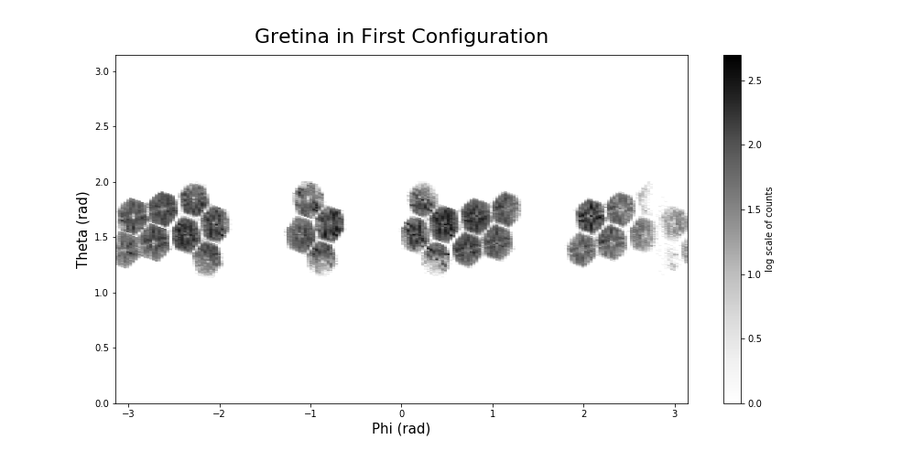

Figure 1. Configuration of Gretina with 28 active hexagonal sections used for both Na-22 experiments.

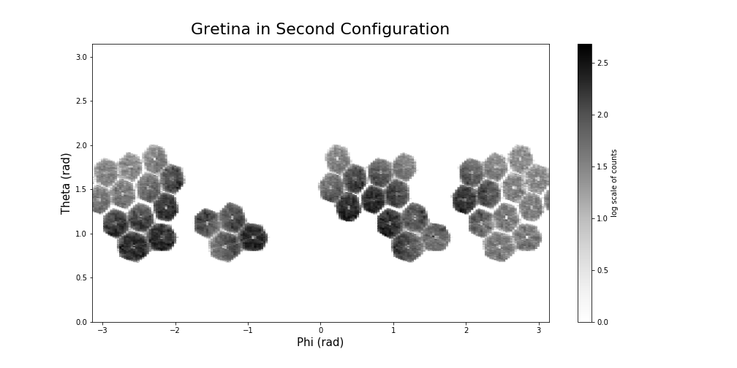

Figure 2. Configuration of Gretina with 40 active hexagonal sections used for the micro-PET phantom.

### microPET Phantom Imaging

Source 3 was a microPET phantom which was provided by the Department of Medical Physics at the University of Wisconsin – Madison [8]. It was fabricated in two parts using 3-D printing with laser cut gaskets and glass-filled nylon nuts and bolts. A small amount of radioactivity was present from previous experiments, and remained after throughout the experiment (0.29 ± 0.02 µCi 54Mn and 0.67 ± 0.01 µCi 57Co). The phantom was filled with 12.9 µCi of Na18F in water. For the phantom experiments, Gretina was operated under the second configuration found in figure 2. Because of this, the phantom was centered in GRETINA’s x-y plane but kept slightly forward in the z plane in hopes of keeping more detector pairings needed for registering two-gamma coincidences.

## Data Reduction

### Two- Gamma data

For the tagging of two 511keV annihilation events in GRETINA a gating procedure using the energies measured in the individual germanium crystals was used. In a first step, all detector energies in an event were added in a calorimeter spectrum, while an event is determined as all detector hits within a time interval of about 100 ns. Only those events were taken into account for further processing which added up to 1022 keV in the calorimeter spectrum. In a next step the add-back procedure as outlined in [9] was employed, which essentially adds the energies of two neighboring crystals together, i.e. treats those events as a scatter from one detector into its neighbor. From the resulting data those events were selected were a pair of energies of 511 keV each could be found. Usually more than one interaction point is reported for detector events of 511 keV energy. For image processing only the coordinates of the first interaction point of a 511 keV hit is of importance and always the interaction point with the highest energy deposition was chosen as such. While this is a very simplistic approach it was shown in [9] that it delivers a better result for extracting the first interaction point compared to employing a gamma-ray energy tracking algorithm.

### Three- Gamma data

Tagging three-photon decays from the 22Na source data was achieved by only considering events in which exactly four detector crystals did fire, one crystal registered a 1275 keV gamma-ray energy, and the energies of the remaining three crystals added up to 1022 keV. In addition, none of those three detector energies was allowed to be larger than 500 keV, reducing the chance for falsely selecting a true-two photon event scattering between three crystals. Exploiting the lifetime of ortho-positronium, calculated as 142 ns [10], a timing condition was set that all three detectors were delayed at least by 40 ns and up to 250 ns with respect to the detector which detected the prompt 1275 keV energy from the daughter 22Ne. It has to be noted that the timing properties of the GRETINA detectors at those lower energies exhibit a slow response component which can be mistaken as a delayed gamma ray, see [9]. The remaining events were further filtered by demanding that each of the three detector pairs forms an angle between 20o and 160o with respect to the center of the detector array where the source was placed.

### Three- Gamma control data

As the extracted yield of three-photon decay events was very small and to ensure that the results from the imaging processing is not just an artifact from the selection procedure of the events, two control data sets were constructed. In a data set measured with 60Co, events were selected with three detectors adding up to 1022 keV and none of the detectors exceeding 500 keV, similar to the energy conditions used for the three-photon selection in 22Na. Of course, in the case of 60Co those events must be Compton-scattered 1.17 MeV and 1.33 MeV gamma-rays not completely absorbed in the GRETINA array. Similarly, events were selected from the 22Na measurement. Here, same gating as for the 60Co source was used but the energy gate on the calorimeter spectrum was actually moved a little higher to 1030 keV. This ensured that those events cannot be formed by just the annihilation gamma-rays of a positron but must have contributions from the 1275 keV gamma ray.

## Reconstructions

### Two-Gamma Reconstructions

#### 2-Dimensional

For 2-D reconstructions, the data initially were compressed in the *z*-axis by setting the *z* value of each detection to zero. In both configurations, GRETINA was assumed to be a planar array. The focus was on the center between the detectors, and the detectors were relatively far from the focus (*Ø* = 40 cm) compared to the size of the object being imaged (22Na source *Ø* = 10 mm, and 18F phantom *Ø* = 8 cm*)* making a planar array a reasonable approximation.

After flattening the data into a 2-D plane, the event Lines-of-Response were binned by their polar angle to create a sinogram. The sinogram was then converted to a tomograph using Scikit-Image’s “iradon” function [11]. This function reconstructs a tomograph using filtered back projection with a simple ramp filter. It is worth noting that iterative reconstruction methods were also tested, in particular, the Simultaneous Algebraic Reconstruction Technique or SART. SART did not lead to more useful pictures and were complicated by the fact that the GRETINA array did not form a complete ring.

#### 3-Dimensional

For the reconstructions in 3-D, lines of response were binned based upon their perpendicular intersection with a plane. The planes were described by normal vectors with polar angle θ (bin size = π/50 radians) and azimuthal angle, φ (φ bin size = π/90 radians). Most of the data fell between θ = [π/3, 2π/3] due to the configuration of GRETINA while the azimuthal swept through [0, 2π]. A sinogram was created from combining these planes which was projected into a 3-D grid of voxels. No filtering was used on the 3-D back projection as it increased computational time drastically. Each pixel with a specific weight was looped through and a 3-D Bresenham line algorithm was used to determine which voxels are updated with the weight of the specific weight from the sinogram. After the 3-D grid of voxels was created, the opengl.GLVolumeItem function was used from the pyqtgraph library to visualize the reconstruction in an interactive way [12].

### Three Gamma Triangulation

Unlike the two-gamma case, the three-gamma decay can be reconstructed back to a single point of decay. Gajos et. all proposed to solve for the point of annihilation with trilateration based upon knowing the detected photon’s position and time [13]. Here, instead of relying on the fast timing of the jPET detector, GETINA’s energy resolution is utilized. From the energy, the angles between the outgoing photons can be uniquely determined. By coupling this kinematic information with the points of detection, the point of annihilation can be found by triangulation.

The first step in triangulation reconstruction is to determine the angles between each photon by utilizing conservation of momentum for the total annihilation interaction. This gives the angles between the momentum vectors as functions of the energies of each photon. When linearly transformed, these vectors point in the direction of their detection points, as seen in Figure 3.

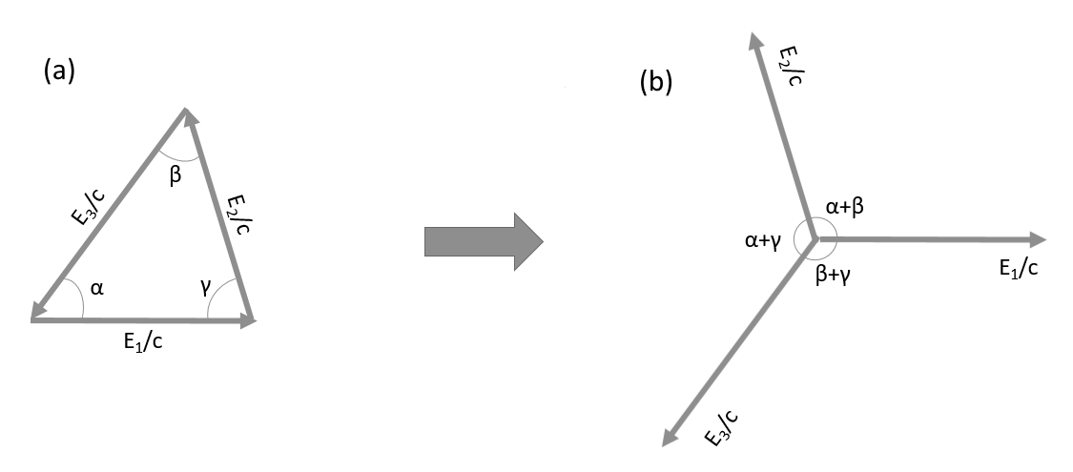

Figure 3. a) Conservation of Momentum vectors cancel leaving angles between. b) vectors point to detection points

An arc of the possible decay positions can be swept out inside the detector using one of the combinations of α, β, and γ as an inscribed angle as well as the two detections the angle points to. Three arcs can be extrapolated within the circle of detectors using each angle in combination with the related points of detection. These three arcs all intersect at one point, the point of decay, as seen in Figure 4. An in depth explanation of the method used for this study can be found in the appendix under the three gamma triangulation algorithm.

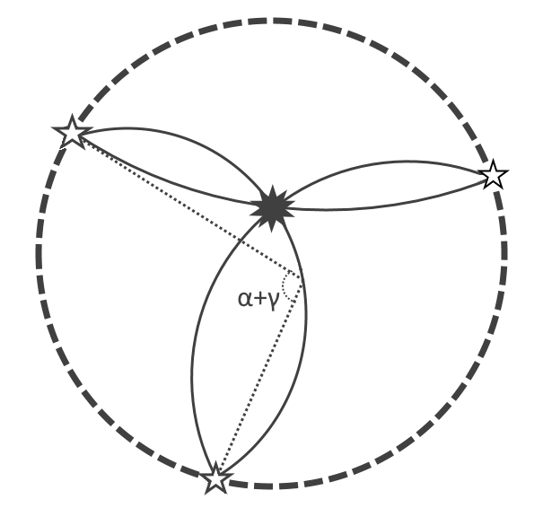

Figure 4. Diagram of reconstruction with the 3 arcs intersecting at the point of decay. One of the inscribed angles are labeled with the five pointed stars being the location for where the gamma was detected.

## Simulations

Monte-Carlo simulations were used to validate the reconstruction algorithms and to facilitate error analysis. The three-gamma decays were simulated by randomly assigning energies to the three annihilation photons while constraining the total energy to 1022 keV and constraining all three photons to have less than 511 keV. (Note that it is possible to make a more rigorous distribution of 3-photon events by using the Ore-Powell distribution [14]). Then an initial decay direction is randomly picked for one of the photons. The other two detection positions are then calculated.

For the two-gamma decays there was no need for energy randomization. Due to the fact that the GRETINA array was not a complete ring, the direction of each photon pair was randomly assigned and checked based upon a probability distribution function. The probability distribution function used was the configuration heat maps found in figures 1 and 2 based upon the distribution from real data. Finally, in order to understand the effect of the interaction-point precision, error was added on to the detection positions in a normal distribution with a standard deviation of 3 mm.

# Results

## Two Gamma Reconstructions

For Source 1, the 0.01 μCi Na-22 source, data were reconstructed as one data set. The source had been moved to six different positions during the experiment, nominally: “12 o’clock”, “3 o’clock”, “6 o’clock”, “9 o’clock”, “centered”, and “downstream”. In the 2-D reconstruction, only five of the six data sets were combined as the “centered” and “downstream” points overlap in z compression. Eliminating the downstream data, the tomograph is shown in Figure 5(left). In the reconstruction, 5 distinct points are visible with the clock labels corresponding as if a clock was centered between all the points. For the same data set, but including the downstream data, the 3-D reconstruction is displayed in Figure 5(right), where the “centered” and “downstream” points are resolved.

The effects of the unoptimized detector geometry is qualitatively visible in the reconstructions. For figure 5, the detector geometry in the first configuration causes a back-projection with an “x” pattern. This originates from gaps 180° from each other where the detectors aren’t paired. Because of this, the reconstructions are skewed towards the detector positions.

Source 1 in Three-Dimensions

Source 1 in Two-Dimensions

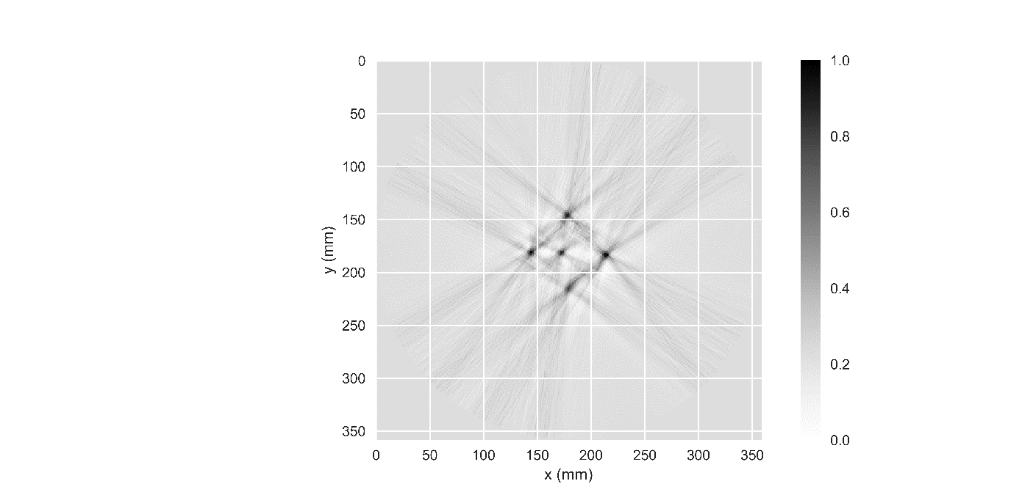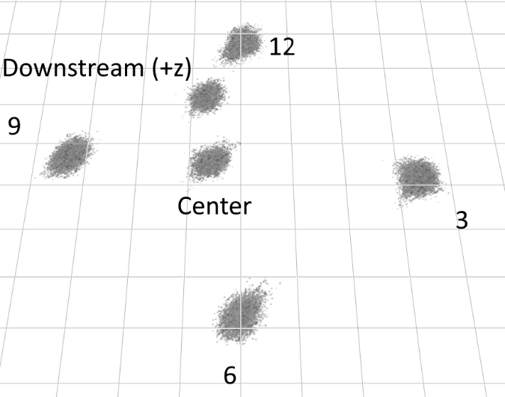

Figure 5 (left) 2-D reconstruction of source 1 with each pixel 1x1mm and a 50x50mm grid overlaid. The z-axis was flattened and the downstream data point was removed as it just reconstructs on top of the center point. (right) 3-D reconstruction of the same data plus downstream at a slight angle. The downstream point is in the positive z direction. The linear slider was set to 0.5, each voxel is 0.25x0.25mm, and the grid is 10x10mm segments.

The second reconstruction done for two-gamma PET was done on source 3, the microPET phantom. The reconstruction as well as an overlay of the phantom’s rod diameters can be seen in Figure 6. The detector set up is described earlier in the methods with the second configuration. The reconstruction resulted in a similar cross pattern as the reconstruction from the first configuration except the (*-x,+y*) to (*+x,-y*) lines result from the out of plane detectors.

While the points were able to be resolved before in the Source 1 reconstructions, the phantom columns were not resolved. In this case the activity distribution was much more compact than in the Source 1 experiment, and spacing between the rods was lower than what could be resolved. However, the sections between the triangle-shaped wedges were clearly visualized. These sections show up in the reconstruction as the lighter sections creating a cross pattern in the center of the image. There is one missing line that would complete the cross pattern that would run horizontally through the image, but it lines up perfectly along the “+” shape where there were no detector pairs (Configuration 2). Without the back projection along that direction, the reconstruction could not highlight the aisle that would split the last set of wedges.

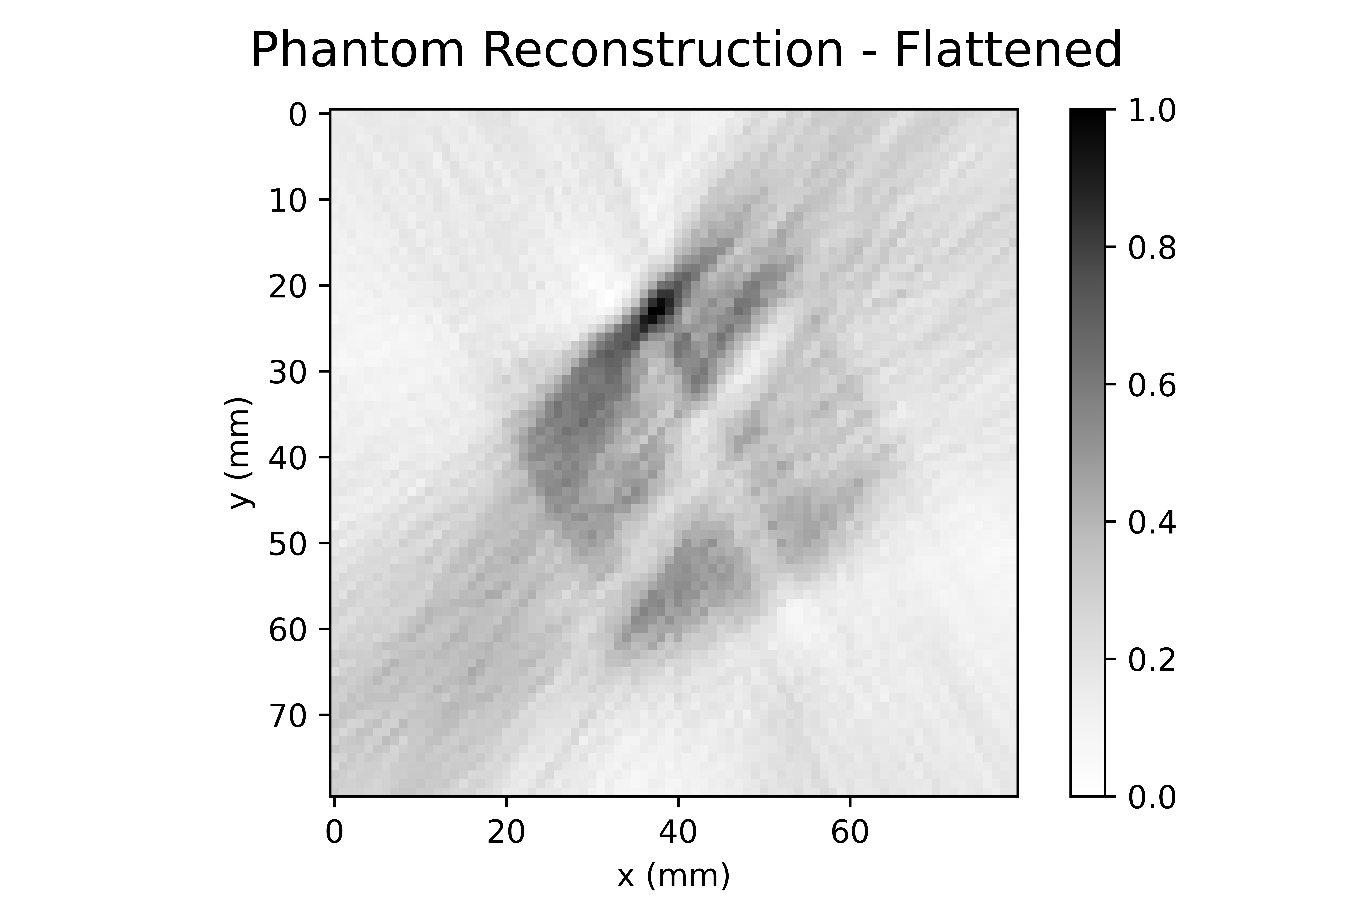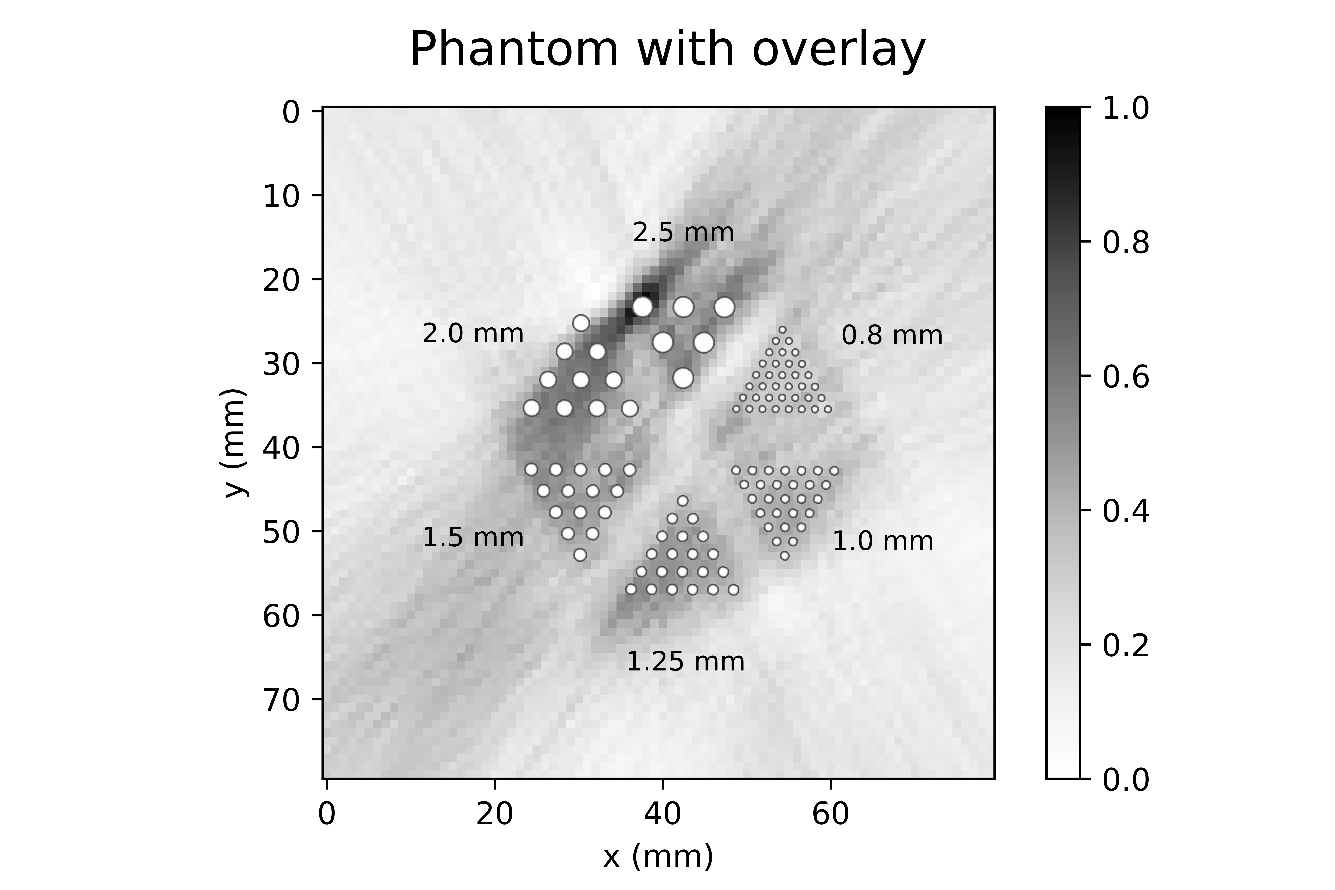

Figure 6. (left) Phantom reconstruction in 2-D by flattening the z-axis from real data. (right) The same phantom reconstruction with overlaid tube sizes. The overlaid phantom shows the diameter of the tubes while the center to center distance is twice the tube diameter. The aisle between the wedges differs but is approximately 7mm.

Simulations of the phantom accounting for detector geometry and detector position resolution were used to confirm that the phantom reconstruction in figure 6 was accurate. The data for the phantom was weighted to represent the volume in each tube, the random angle of detection is compared to the probability distribution function of the actual data’s angular distribution, and the detection position of each point is smeared by a normal distribution with a standard deviation of 3 mm. The reconstruction of this simulation can be seen in Figure 7 along with an overlay to show the size of the rods. Compared to figure 6, the simulated data results in the same loss of resolution within each wedge and the loss of the horizontal cross pattern can be seen.

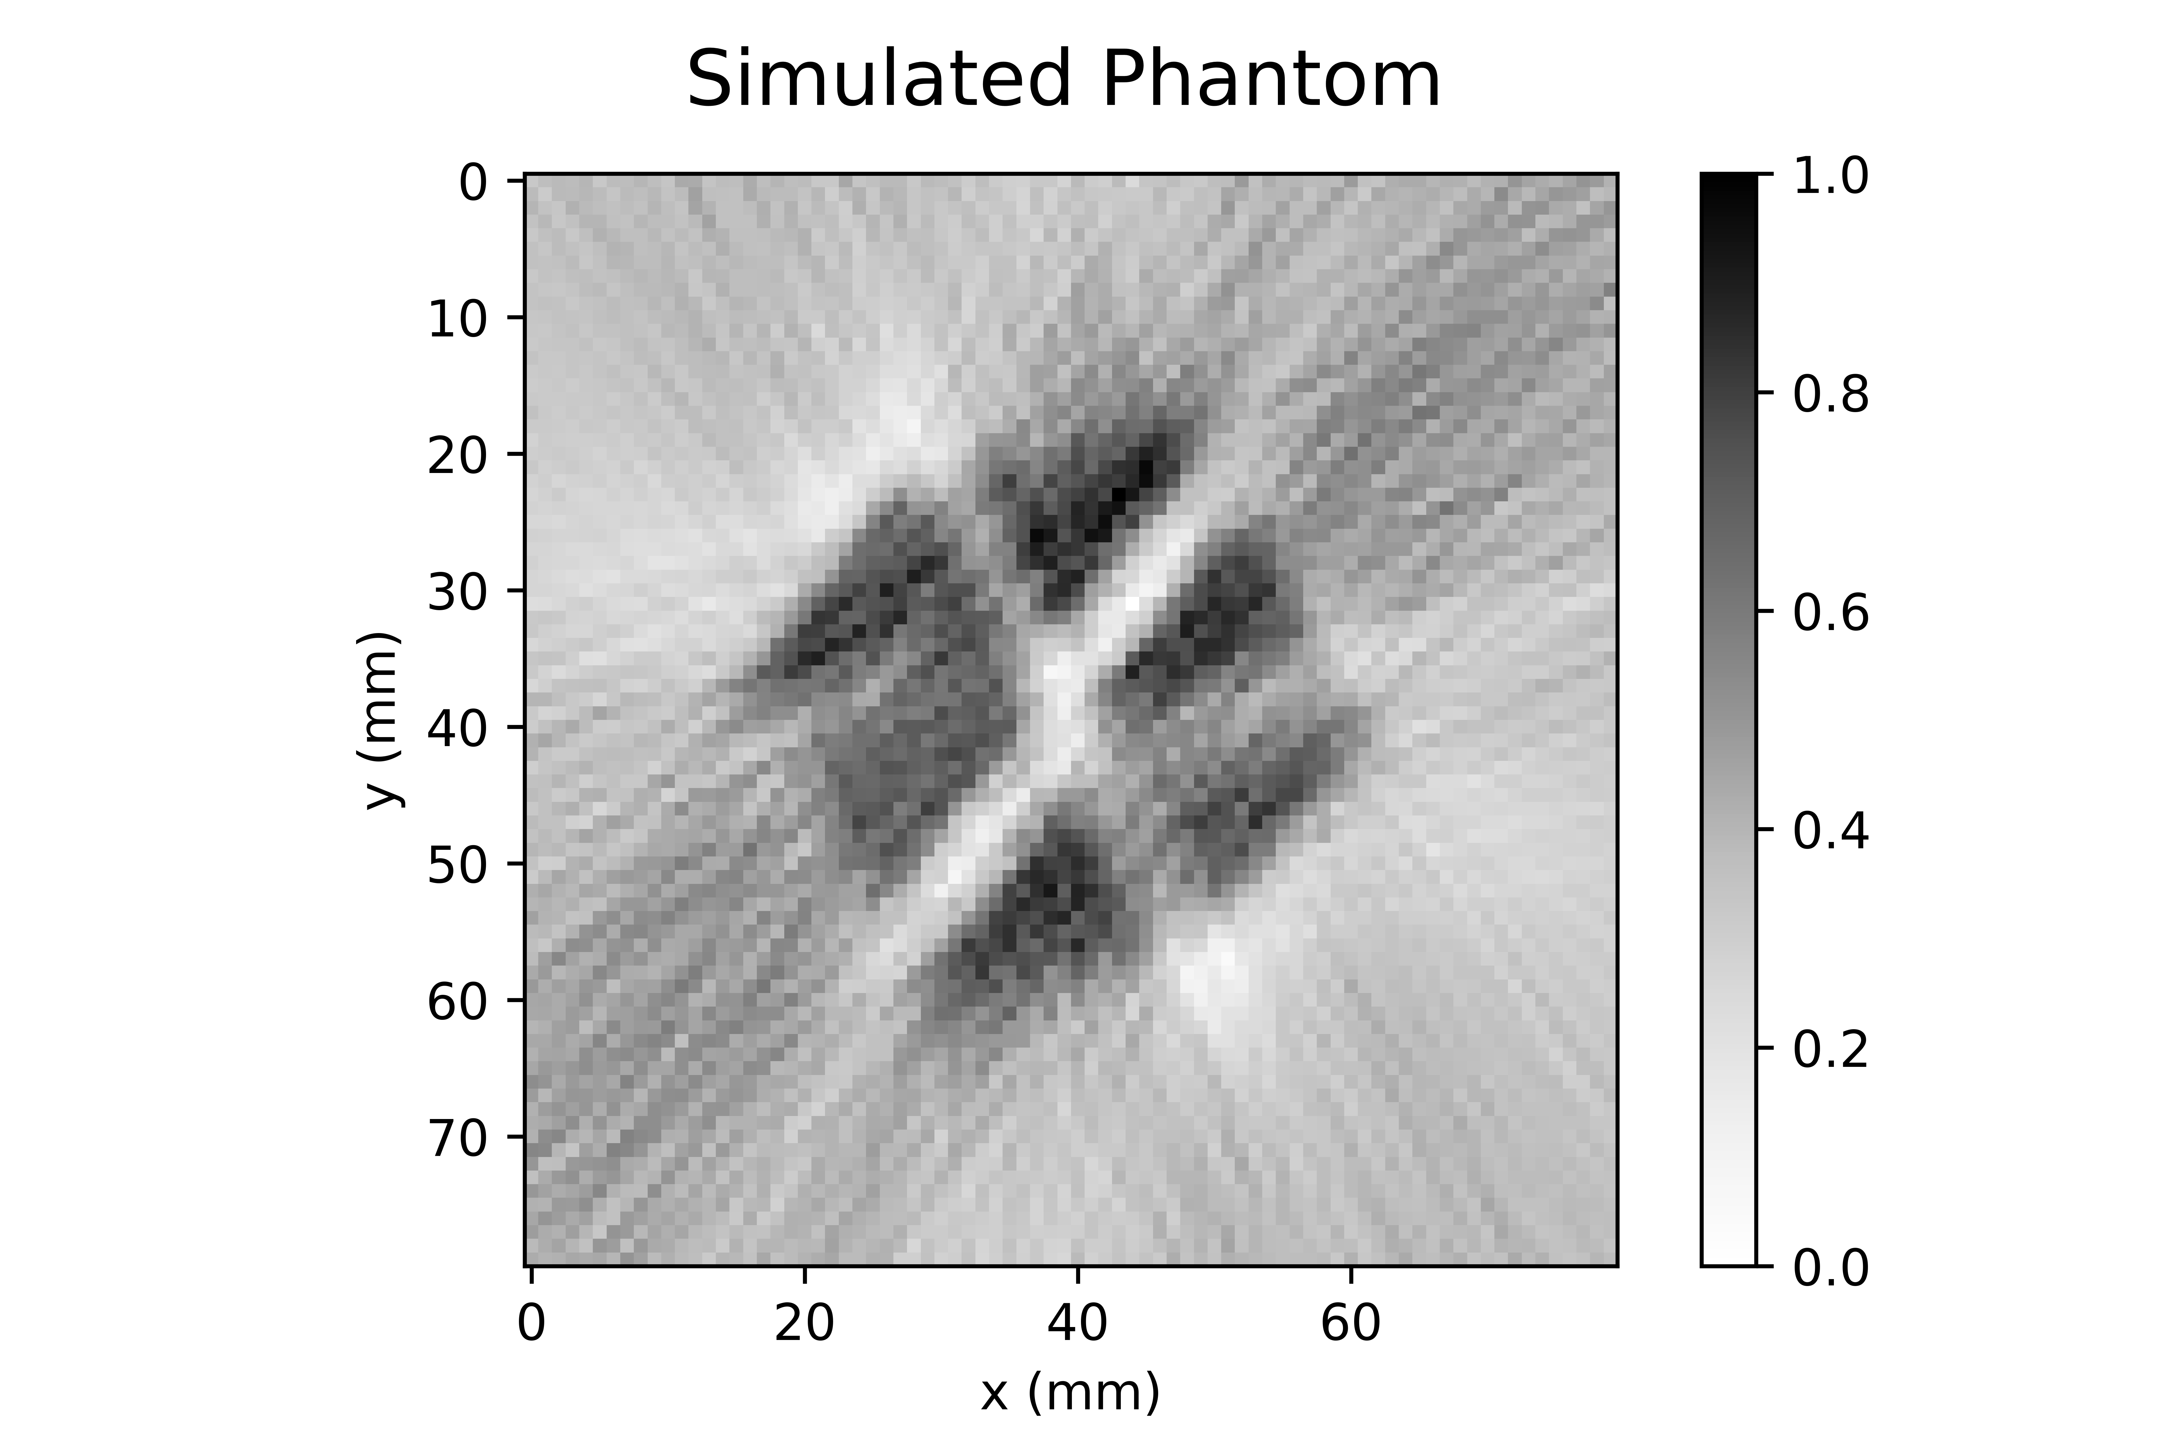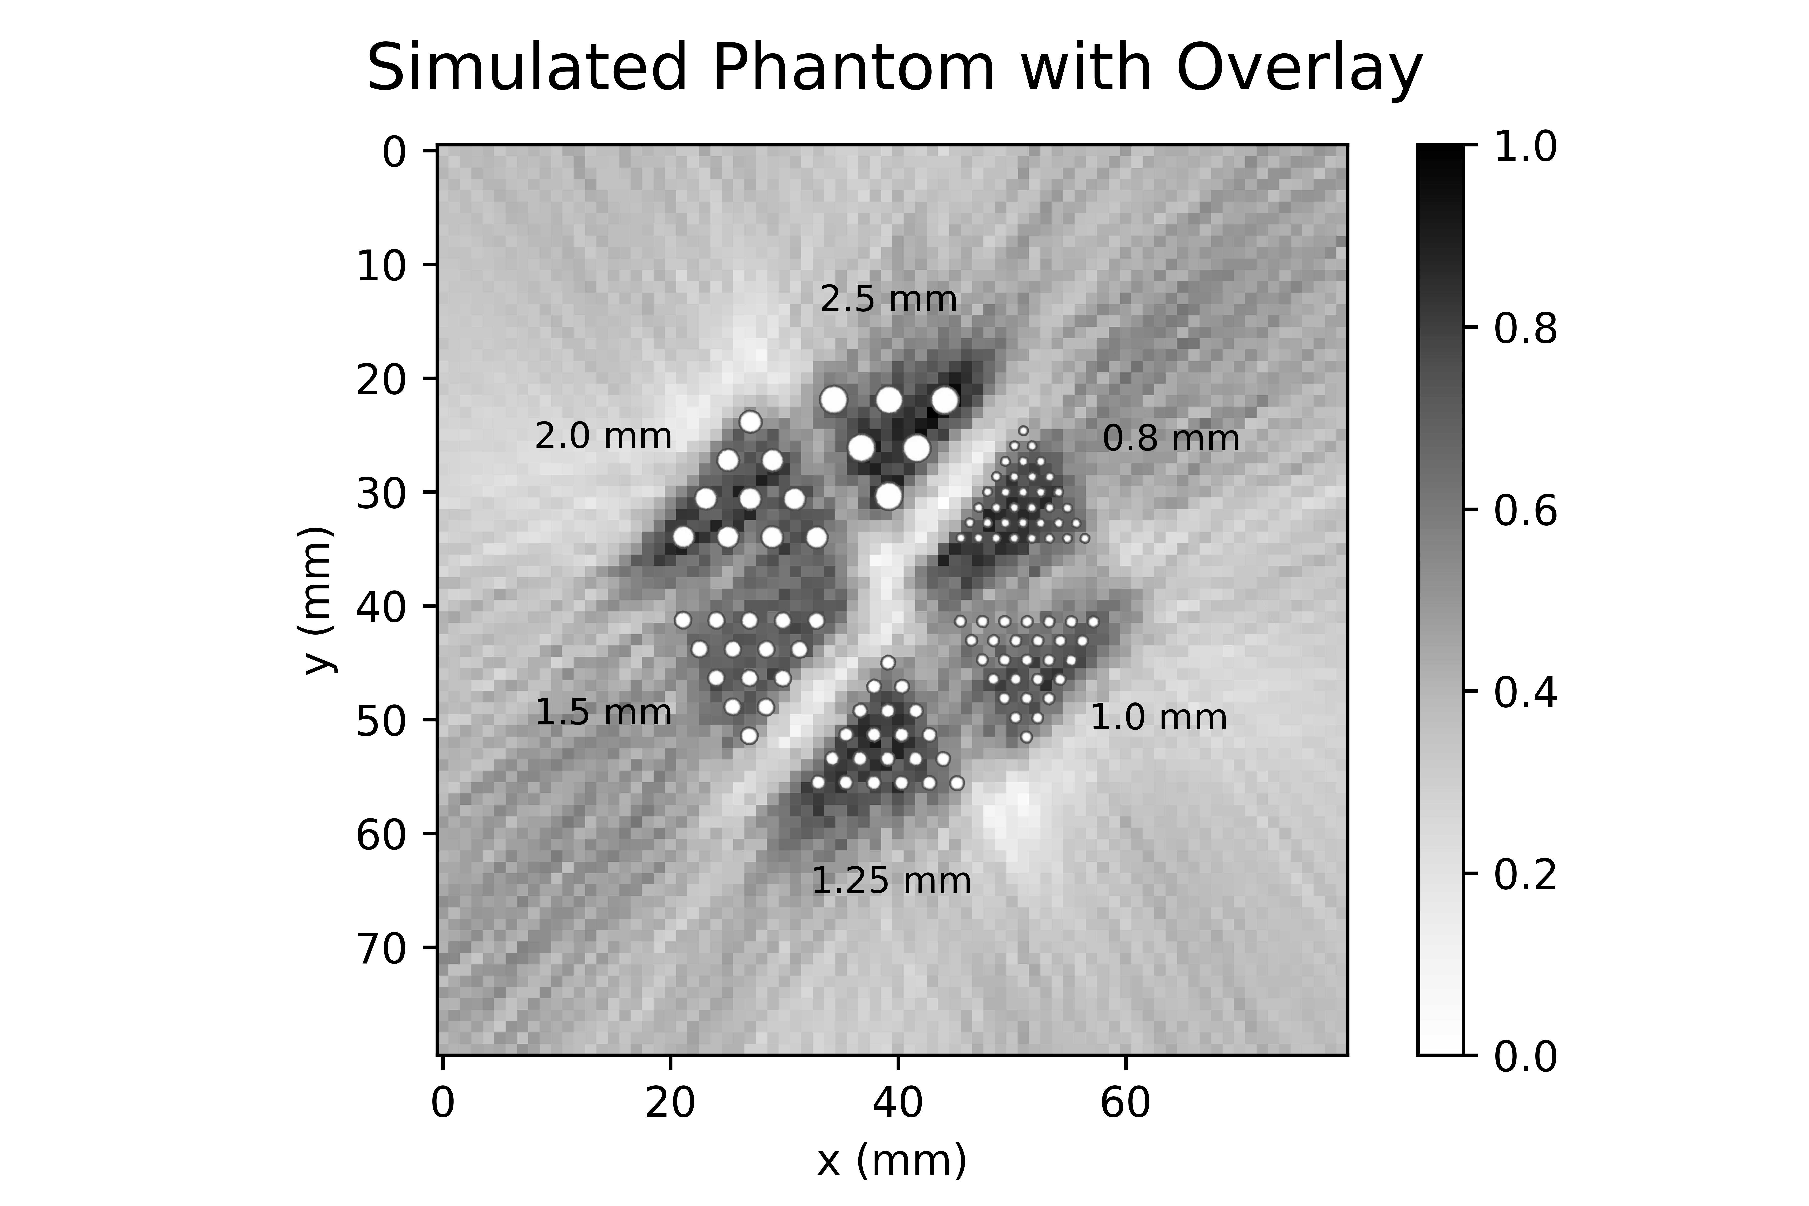

Figure 7. (left) Reconstruction of the simulations with errors. A Monte Carlo method was used based on the angular distribution of detections from the real data in combination with a σ = 3mm normalized detection error on the detection position added on. (right) The same reconstruction with an overlaid phantom showing the size of the holes.

The same phantom data can be seen reconstructed in 3-D in Figure 8(left). The results of this reconstruction are undeniably poor in comparison to the 2-D reconstruction in figure 6 as well as in comparison to the simulated phantom. A major factor in the difference between the flattened and full 3-D image was the lack of the Fourier transform that filters the 2-D reconstruction. The 3-D algorithm was a simple back projection rather than a filtered back projection because of computational time constraints. The difference between the reconstructions of the real data and the simulated data are due to differences in background as well as the real data having constraints on detector pairing geometry.

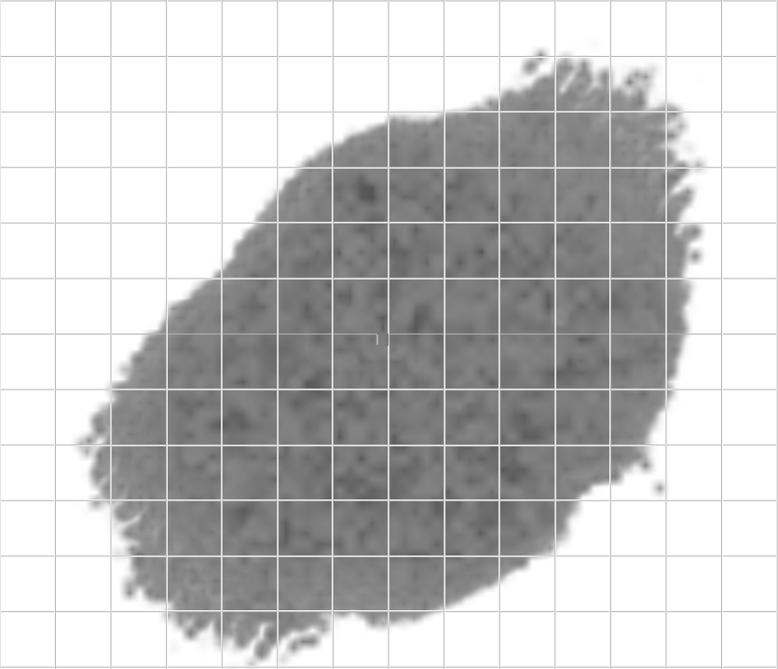 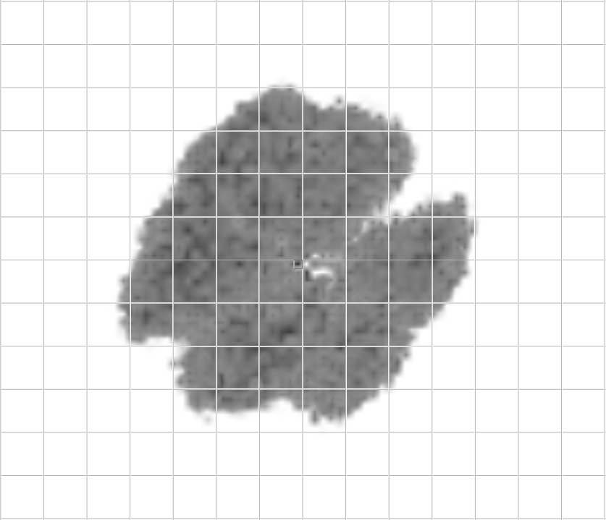

Simulated Phantom in 3-D

Phantom Data in 3-D

Figure 8. (left) 3-D reconstruction of experimental phantom data. (right) 3-D reconstruction of simulated phantom data. Both have 1x1mm voxels and are on a 10x10mm grid looking directly down the z axis.

As discussed earlier, the available detector angles in Configurations 1 & 2 led to skewing of the reconstruction. In the 3-D reconstruction of the Source 1 data, seen in figure 5, the central point is skewed heavily to the bottom left/top right direction. Because of this, the 3-D case was analyzed relative to the direction of maximum variance. The 2-D reconstruction was simply analyzed along the x-y axis seen in figure 5(left). The z resolution was measured with a y-axis compression.

For the full width half max (FWHM) calculations, a series of lines were taken through the data set of weights and a Gaussian distribution is fit to get the FWHM. For the central point in the 2-D reconstruction, the *x* direction had a FWHM of 7.40 mm while the ydirection had a FWHM of 6.00 mm. For the 3-D case and central point, the maximum variance had a standard deviation of 10.17 mm, the minimum variance had 6.85 mm, and the z-direction had 5.75 mm. The FWHM for the other positions of the source are summarized in Table 1.

Table 1. FWHMs of reconstructed data obtained from a 6 mm (flat circle) Na-22 source (Source 1). The 2-D images were analyzed in the x-y directions and the 3-D images were analyzed with *direction 1* being the direction of maximum variance and *direction 2* being orthogonal (minimum variance). The z-axis is axial, according to the cylindrical approximation of the GRETINA array.

|  |  |  |  |  |  |  |
| --- | --- | --- | --- | --- | --- | --- |
| Point Position | 2-D | | | 3-D | | |
| FWHM x | FWHM y | FWHM z | FWHM1 | FWHM2 | FWHMz |
| 12 o'clock | 6.77 | 7.24 | 3.83 | 13.26 | 9.89 | 6.01 |
| 3 o'clock | 7.47 | 7.73 | 3.82 | 8.36 | 12.25 | 5.58 |
| 6 o'clock | 7.76 | 9.38 | 5.77 | 17.38 | 8.78 | 7.44 |
| 9 o'clock | 7.13 | 6.17 | 3.88 | 13.38 | 7.87 | 6.12 |
| Center | 7.40 | 6.00 | 4.14 | 10.17 | 6.85 | 5.75 |
| Downstream | x | x | x | 10.31 | 9.09 | 5.51 |

Generally, in the 2-D case, the x and y resolution is comparable with an overall average of 7.31 mm. In 3-D, when the directions are rotated, the resolution from the direction of variance corresponds to which set of detectors had the highest ratio of counts. Overall, the z resolution is better than the other directions but in an artificial manner. More detector coverage in 180-degree pairs would alleviate much of the observed stretching.

## Three Gamma Reconstructions

The data obtained from Source 1 were also analyzed for three-photon annihilation events. With detector pairs forming an angle between 20°-160°, described above in the methods/data reduction section, only 91 suspected true three gamma events were retained, which reconstructed to the image seen on the left of Figure 9. The reconstruction struggles with the lack of data but some activity in the center can be observed with less confidence that there is activity around it at the 3, 9, and 12 o’clock positions. Without the angle cuts, 572 points of data were extracted with the reconstruction of this data set seen in right side of Figure 9. False reconstructions start building up in the location of the detectors without gaining much additional resolution in the center. These are suspected to be due to Compton scattering within the detector that originated from a 2 gamma decay where one photon deposited the correct energy in two different segments that were next to each other. This same pattern was observed later in the source 2 data set as well.

All Source 1 – Three-Gamma Events

Reduced Source 1 – Three-Gamma Events

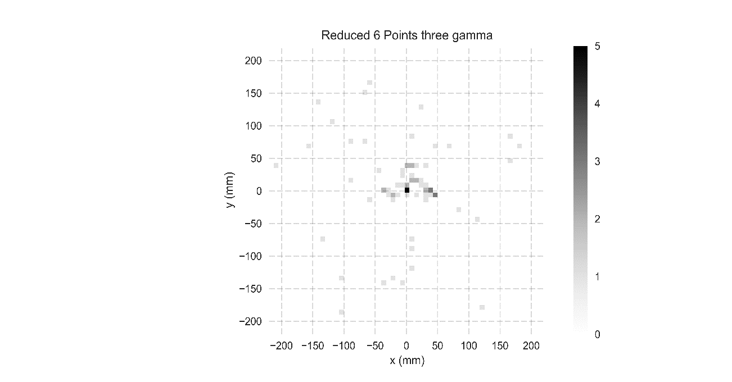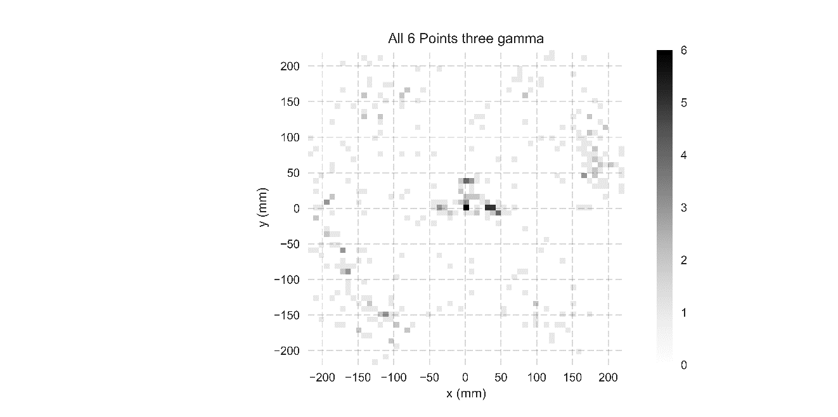

Figure 9. 2-D histogram of three gamma reconstructions on the source 1, 0.01µCi Na-22 data set. (left) reduced data based on the angle cuts made to the data. (right) All possible three gamma events with reconstructions within the area of the detector. Bins in both are set to 7.5x7.5 mm.

The lack of data from Source 1 motivated the Source 2 experiments, with a higher source activity, and a longer data collection period. For this data set, 2001 suspected true three gamma events were collected and reconstructed. The reconstruction can be seen in Figure 10. The single 10mm diameter, thin cylinder- source, centered slightly off center, provided data that reconstructed with a FWHM of 15.92 mm in the *x*, 19.07 mm in the *y*, and 13.23 mm in the *z* dimensions.

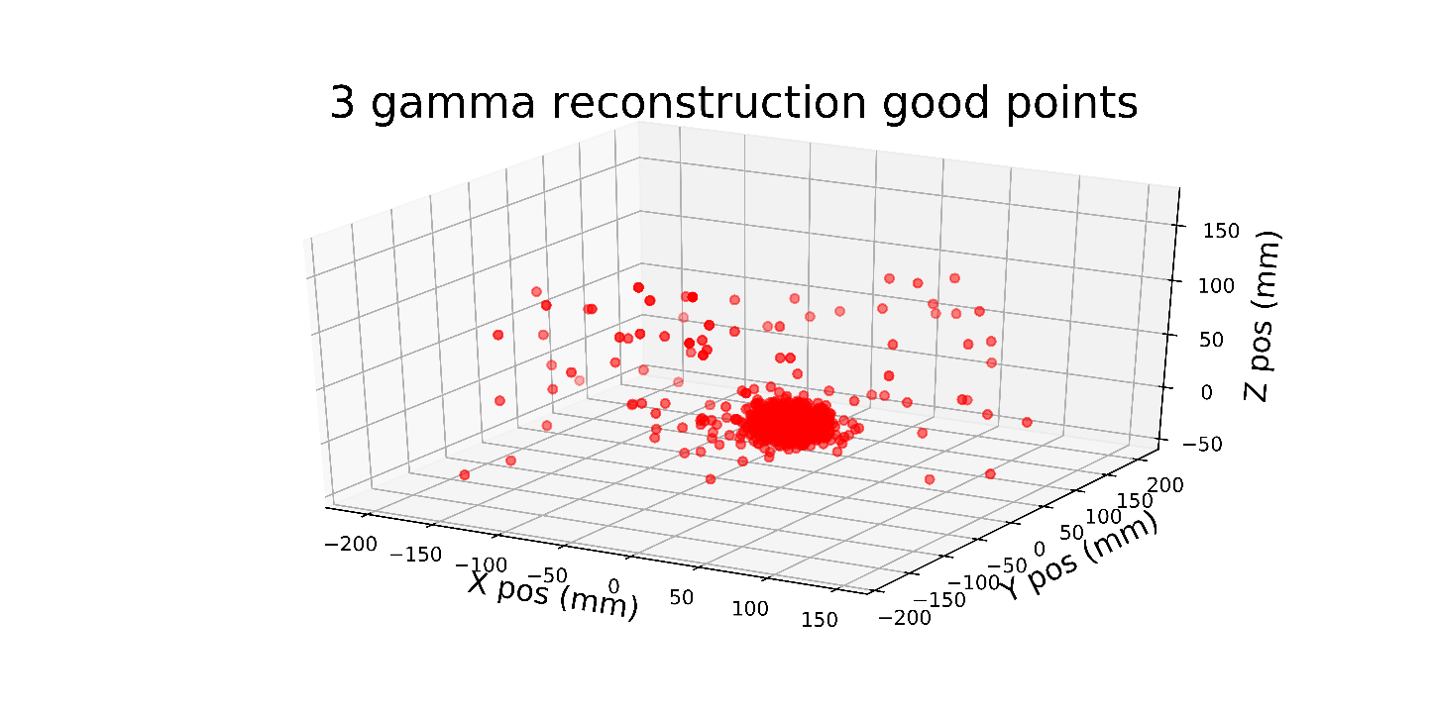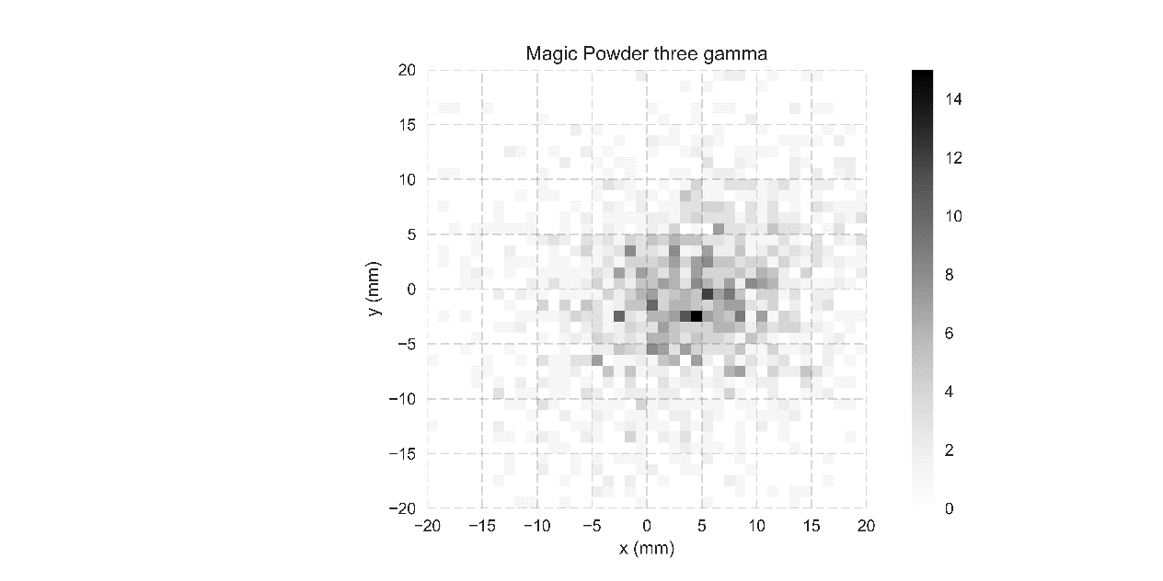

Scatter Plot of Source 2 Reconstructions

Heat Map of Source 2

Figure 10. (left) 3-D scatter plot of all the reconstructed points in the source 2 data set with 2001 three-gamma events. (right) Heat map of the center to show the shape of the central blob.

To confirm that the reconstruction algorithm was suitable, for example, to see that false events do not naturally reconstruct to the center of the field of view, two trials were run. One used a sealed cobalt-60 source at the center of the detector array, and employed the same data cuts that were used to reduce the Source 1 and Source 2 data sets. The other trial used data from the Source 2 run, but rather than selecting 3-photon events adding to 1022 keV, events adding to 1032 keV were selected.

The cobalt source lacked a β+ decay to create positronium for the three gamma events but it did have two high energy gamma rays that are similar to the 1275 keV gamma originating from sodium-22 decay. The reconstruction of this data can be seen in figure 11(left). This reconstruction had similar events to source 1 all-possible-events where Compton scattering events reconstructed primarily inside of the detector.

The sodium-22 (Source 2) dataset with incorrect energy values reconstructed in a more uniform distribution (seen in figure 11(right)). They were close to the correct energy being only ~10 keV away from the 1022 keV needed for a true three gamma event. Out of 4801 detector coincidences, 3323 were able to be reconstructed with many of these failing because they reconstruct outside of the detector’s radius. Out of those, 63 points reconstruct within a 20 mm radius from the center. While this initially looks like natural reconstruction in the center, it is only slightly more than 0.01% of the total coincidences. This has no possibility to be a two gamma event that scattered making it look three gamma event because the energy cuts were taken above the 1022 keV mark. There is still a 1275 keV gamma that could interact with a scattered 511 keV gamma or even a capture of two out of three gammas from a real three gamma event.

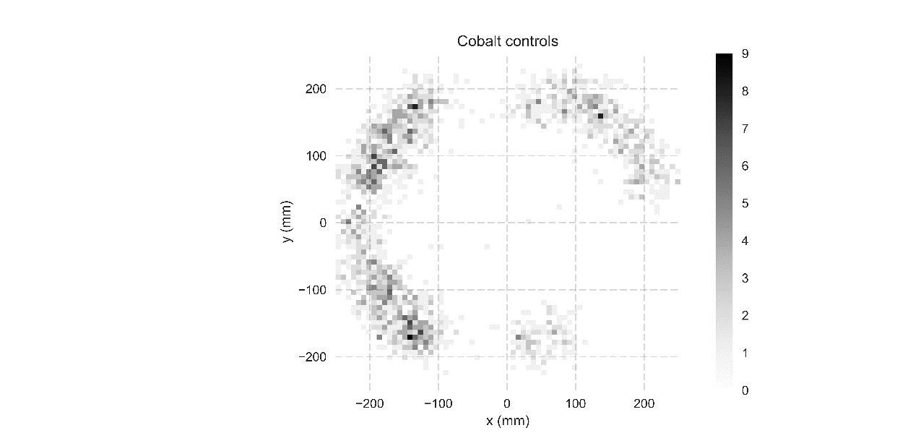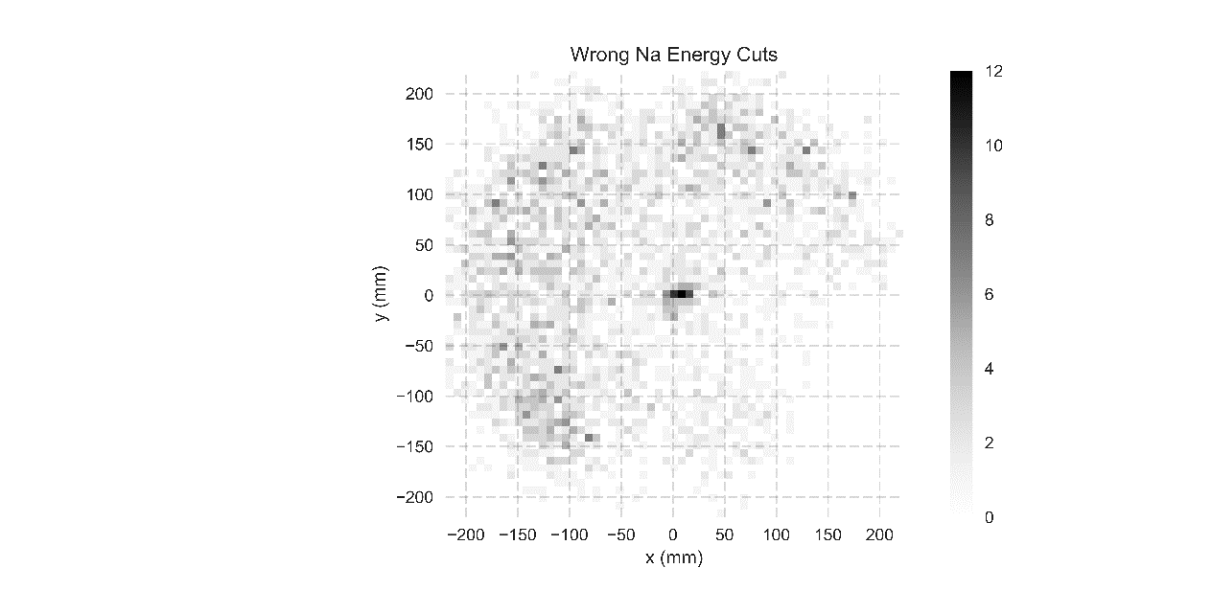

Wrong Na Energy Reconstruction

Cobalt Controls Reconstructions

Figure 11. (left) Cobalt-60, a β- emitting source with the same data reduction used for all three gamma data. (right) Sodium-22 source with energy peaks centered around 1031 keV with the same data reduction used for all three gamma data.

The effects of the inherent energy and position resolution of GRETINA were studied using the simulation of a three gamma decay. With a perfect point in the center, noise was added on with a normal distribution for either the interaction point, or the photon energy. With the energy smeared by a standard deviation of 2 keV, the reconstructed point had a median distance of 1.01 mm from the center, only half of the induced error. With the interaction point of each detection smeared by a standard deviation of 5 mm (a high estimation for the uncertainty of GRETINA), the reconstructed point had a median distance of 5.19 mm from the center. This means that image resolution is likely dominated by the position uncertainty in the detection of photons.

The resolution as a function of position within the field of view of the detector was also analyzed in terms of energy and interaction-point imprecision in order to determine if the variance in the reconstruction had any radial dependence. With a perfect ring of detectors, a grid search was done giving the same position and energy error as above while calculating the median error from the original spot. It was found in figure 12(left) that reconstruction error was minimized as the annihilation energy was evenly distributed between the three photons (*e1=e2=e3=1022/3* keV). The error only spikes up drastically when one energy is small enough that a change in 2 keV is a large fractional error. No event like this was present any of the experimental three gamma data. The reconstruction uncertainty as a function of annihilation position within the detector showed a low point at the center with very little radial dependence. The median distance from the original point can be seen as a function of position in Figure 12(right).

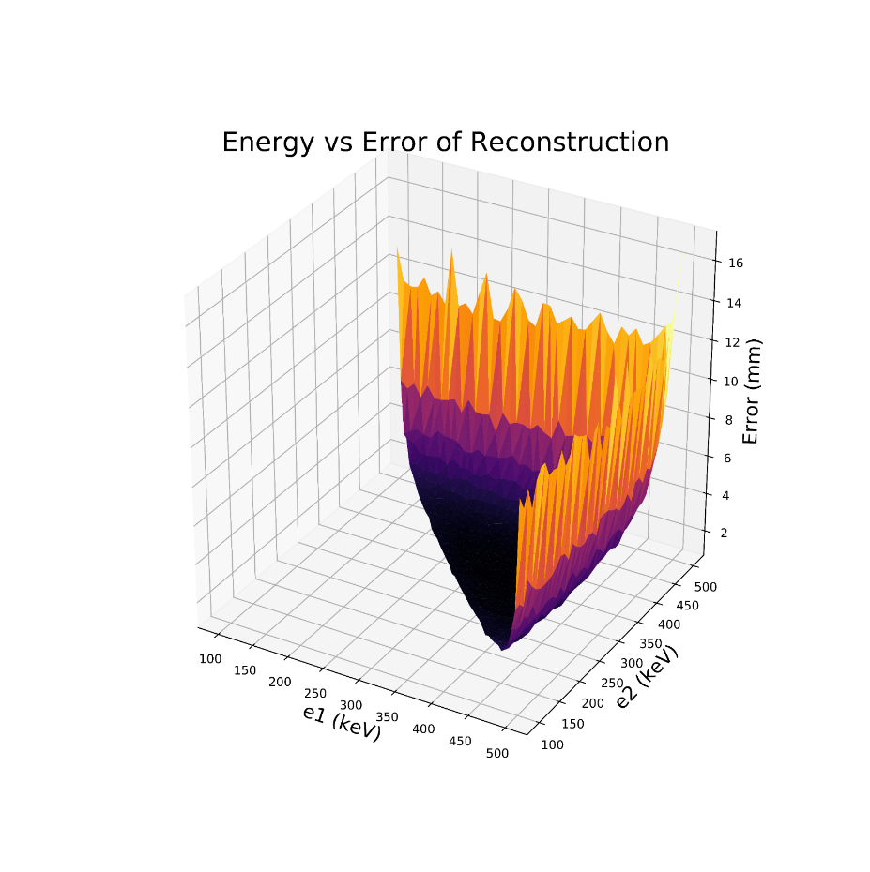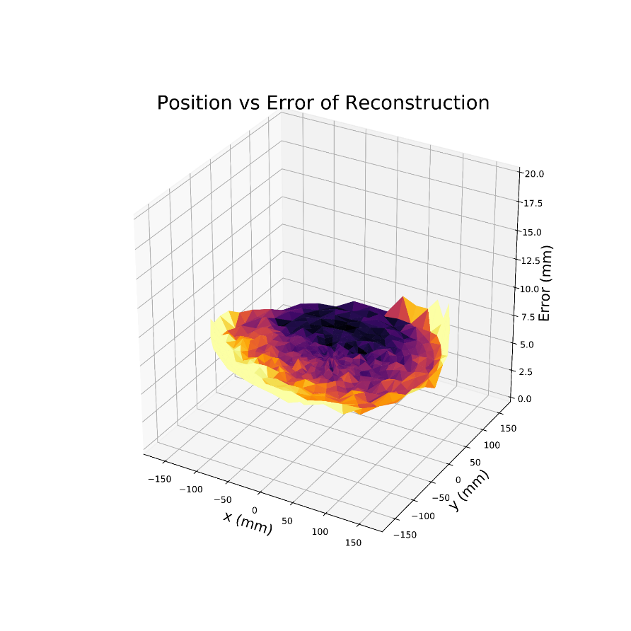

Error as a Function of Position

Error as a Function of Energy

Figure 12. (left) simulated mean distance between source points and reconstructed points as a function of the energy distribution, and (right) simulated mean distance between source points and reconstructed points as a function of source position within the detector.

# Discussion

This experiment was a chance to use the leading edge of nuclear physics instrumentation in combination with imaging techniques developed by the medical community. With this combination, the potential utility of the superior energy resolution compared to current PET detectors was examined. With this higher energy resolution, different data reduction techniques for the two-gamma imaging were implemented. The SmartPET system, which is a HPGe detector specifically designed for PET imaging explored rejection of scattering based on high energy resolution [15]. Imaging with GRETINA expanded this by using gamma-ray tracking to determine the position within the germanium as well as adding on PET imaging using the three-gamma decay.

In this study, two gamma PET with Source 1, 0.01 µCi Na-22, data had x-y spatial resolution of 7.3 mm FWHM averaged over all the points in the 2-D tomograph. The 3-D case of the source 1 data was less accurate with an average resolution of 12.1 mm for variance direction 1 and 9.1 mm for direction 2. The combination of stretching from the unoptimized detector geometry as well as the detection position sensitivity mostly accounts for the loss in special resolution as shown by the Monte Carlo simulation. There is still room for improvement when reducing the number of random two photon coincidences but this only has a small contribution to the image resolution presented here, as the activity of the sources were low.

For the three gamma imaging data, the 10 mm diameter thin-film source (Source 2) was reconstructed with a FWHM of 15.9 mm in the *x* direction and 19.1 mm in the *y* direction. Some of the justification for loss of resolution in the three-photon reconstruction were discussed earlier in the results section, namely the inherent interaction-point precision and energy resolution of GRETINA. Other sources that would contribute to a loss in resolution would be scattering events from multiple two gamma decays or positron drift. For positron drift, the ~1 mm range for positrons from Na-22 decay is negligible compared to the other sources of uncertainty [16]. The main factor affecting three photon decay reconstructions is the low probability of occurrence compared to two photon decay. The Source 1 data set only contained 91 suspected true three gamma events, which was insufficient to resolve more than the central point. The Source 2 data set held 2001 suspected true three gamma events giving a clear picture of the source in three dimensions.

This result highlights one of the main drawbacks to three-gamma PET imaging, the relatively low number of positronium decays leading to a three-gamma event. The ortho-positronium will convert to the para- form when interacting with matter which quickly decays. For a free positron, the ratio of decays compared to the two photon case is approximately 370:1 [14]. This changes based on the medium, with water being around 0.5% three photon decays and some alkaline oxides reaching as high as 20% [17]. As the geometry of the detector comes into play, the percent of decays further decreases. Currently, the GRETINA array covers 1-pi of its solid angle, but the successor to GRETINA, GRETA, is planned to be a 4-pi detector [5].

Even ahead of the GRETA upgrade, improvements in resolution are also available if GRETINA is rearranged as a ring. With the missing detector angles returned, the reconstruction could properly weight the two-gamma x- and y- directions equally, giving a much clearer picture of the activity distribution and removing the need to analyze the resolution along the direction of variance. The complete ring configuration also allows iterative reconstructions which can have higher special resolution than filtered back projection. In the future, GRETA, with 4-pi solid angle coverage, will allow for extremely accurate 3-D imaging.

There are some clear benefits to using an array like GRETINA for imaging. It allows for different forms of imaging beyond traditional the-two gamma PET, such as three-gamma imaging shown here, Compton camera imaging [18], and the possibility of combining higher order events. These could be two gamma decay plus a Compton cone, three gamma decay plus a Compton cone, or even much rarer events such as a 4 or 5 gamma decays.

Three-gamma reconstructions give insight into Compton scattering events inside the detector as they reconstruct differently (as shown by the Co-60 controls). Gajos et al. proposed to use the three-gamma reconstruction to determine the polarization of β+ decays [13]. There are also possibilities for multi-source PET imaging. With 3rd gamma tagging multiple isotopes can be distinguished from one-another by the spectral identification of a third coincident gamma ray in addition to two annihilation photons. Finally, the three-gamma decay gives instant information upon detection as you can reconstruct each point individually and get feedback mid procedure.

# Conclusion

Two- and three-gamma PET imaging techniques were shown to be viable with a gamma ray tracking detector. For two-gamma PET, 2-D and 3-D imaging was explored using filtered back projection and back projection respectfully. With simple source geometries, the reconstructions gave easily identifiable images. When a more complex source distribution was tested (F-18 phantom), many of the features were left unresolved. This was mainly due to the unoptimized detector geometry in combination with the detector’s inherent position detection resolution.

For the three-gamma imaging, the Source 1 data set produced an image with reconstructions in the center of the detector with the possibility of points at 3, 9, and 12 o’clock. It highlighted the major issue of three gamma imaging, the low event rate. For the second dataset using the higher activity Source 2, and counting for a longer period, many more three-gamma events were recorded, allowing for an analysis on the resolution of three gamma imaging. The cobalt-60 data set, and the sodium-22 data set with deliberately improper energy cuts acted as controls to show that the image reconstruction does not bias results towards the center.

When GRETINA is not making intricate nuclear structure measurements, it has the potential to be a powerful imaging detector with unique benefits. Gamma ray tracking provides a different set of information by giving accurate energy resolution in addition to interaction-point position resolution. Two- and three- gamma imaging with GRETINA is a tool that may eventually open possibilities in medical and basic research. The implementation of this tool needs to be investigated further, and this effort may lead to development of other imaging techniques unique to gamma ray tracking.

# Acknowledgements, References, Supplemental

Funding for this project was provided by Michigan State University. The efforts of Professor Jonathan Engle and Dr. Stephen Graves at the University of Wisconsin-Madison in providing the F-18 phantom, and those of Professor Peter Bender at the University of Massachusetts-Lowell in assisting with data collection are gratefully acknowledged.

[1] B. Gutfilen and G. Valentini, “Editorial Radiopharmaceuticals in Nuclear Medicine : Recent Developments for SPECT and PET Studies,” *BioMed*, vol. 2014, p. 3, 2014.

[2] G. Tarantola, F. Zito, and P. Gerundini, “PET Instrumentation and Reconstruction Algorithms in Whole-Body Applications,” *J. Nucl. Med.*, vol. 44, no. 5, pp. 756–769, 2003.

[3] J. P. Holland, M. J. Williamson, and J. S. Lewis, “Unconventional Nuclides for Radiopharmaceuticals,” *Mol. Imaging*, vol. 9, no. 1, pp. 1–20, 2010.

[4] J. L. Humm, A. Rosenfeld, and A. Del Guerra, “From PET detectors to PET scanners,” *Eur. J. Nucl. Med. Mol. Imaging*, vol. 30, no. 11, pp. 1574–1597, 2003.

[5] S. Paschalis *et al.*, “The performance of the Gamma-Ray Energy Tracking In-beam Nuclear Array GRETINA,” *Nucl. Instruments Methods Phys. Res. Sect. A Accel. Spectrometers, Detect. Assoc. Equip.*, vol. 709, pp. 44–55, 2013.

[6] S. Akkoyun *et al.*, “AGATA - Advanced Gamma Tracking Array,” *Nucl. Instruments Methods Phys. Res. Sect. A Accel. Spectrometers, Detect. Assoc. Equip.*, vol. 668, pp. 26–58, Nov. 2011.

[7] K. Kacperski, N. M. Spyrou, and F. A. Smith, “Three-gamma annihilation imaging in positron emission tomography,” *IEEE Trans. Med. Imaging*, vol. 23, no. 4, pp. 525–529, 2004.

[8] B. L. Cox *et al.*, “Development of a novel linearly-filled Derenzo microPET phantom,” *Am J Nucl Med Mol Imaging*, vol. 6, no. 3, pp. 199–204, 2016.

[9] D. Weisshaar *et al.*, “The performance of the γ-ray tracking array GRETINA for γ-ray spectroscopy with fast beams of rare isotopes,” *Nucl. Instruments Methods Phys. Res. Sect. A Accel. Spectrometers, Detect. Assoc. Equip.*, vol. 847, no. September 2016, pp. 187–198, 2017.

[10] G. S. Adkins, R. N. Fell, and J. Sapirstein, “Order α2 corrections to the decay rate of orthopositronium,” *Phys. Rev. Lett.*, vol. 84, no. 22, pp. 5086–5089, 2000.

[11] S. van der Walt *et al.*, “scikit-image: image processing in Python,” *PeerJ*, vol. 2, p. e453, 2014.

[12] L. Campagnola, “pyqtgraph,” 2011.

[13] A. Gajos *et al.*, “Trilateration-based reconstruction of ortho-positronium decays into three photons with the J-PET detector,” *Nucl. Instruments Methods Phys. Res. Sect. A Accel. Spectrometers, Detect. Assoc. Equip.*, vol. 819, pp. 54–59, 2016.

[14] A. Ore and J. L. Powell, “Three-Photon Annihilation of an Electron Positron Pair,” *Phys. Rev.*, vol. 75, no. 11, p. 1696, 1949.

[15] R. J. Cooper, “Performance of the SmartPET Positron Emission Tomography System for Small Animal Imaging,” no. October, 2007.

[16] C. S. Levin and E. J. Hoffman, “Calculation of positron range and its effect on the fundamental limit of positron emission tomography system spatial resolution Calculation of positron range and its effect on the fundamental limit of positron emission tomography system spatial resolution,” *Phys. Med. Biol.*, vol. 44, pp. 781–799, 1999.

[17] F. H. Hsu$, M. J. Shaot, L. D. Hulettp, T. M. Rosseel, and J. M. Dale, “Three-photon yield of positron annihilation in Cab- O-Sil (SiO 2 ) Three-photon yield Cab-0-Si1 (SiO,)? of positron annihilation in,” *J. Phys. Condens. Matter J. Phys. Condens. Matter l*, vol. 1, pp. 7453–7456, 1989.

[18] S. Moon *et al.*, “Compton imaging with AGATA and SmartPET for DESPEC,” *J. Instrum.*, vol. 6, no. 12, 2011.

# Appendix- Three Gamma Triangulation algorithm

Kacperski describes the problem of a three gamma annihilation at a point r=(x,y,z), with photon energies E1,E2,E3, and detection positions r1,r2,and r3, with a nonlinear system of equations described by conservation of momentum and energy [7]. While it may be possible to solve the system of equations defined by equation 1.

$$p_{x}=\frac{E_{1}}{c}\frac{x-x_{1}}{\left|r-r_{1}\right|}+\frac{E_{2}}{c}\frac{x-x_{2}}{\left|r-r_{2}\right|}+\frac{E_{3}}{c}\frac{x-x_{3}}{\left|r-r_{3}\right|}=0$$

$$p_{y}=\frac{E_{1}}{c}\frac{y-y_{1}}{\left|r-r_{1}\right|}+\frac{E_{2}}{c}\frac{y-y_{2}}{\left|r-r_{2}\right|}+\frac{E_{3}}{c}\frac{y-y_{3}}{\left|r-r_{3}\right|}=0$$

$$p_{z}=\frac{E_{1}}{c}\frac{z-z_{1}}{\left|r-r_{1}\right|}+\frac{E_{2}}{c}\frac{z-z_{2}}{\left|r-r_{2}\right|}+\frac{E_{3}}{c}\frac{z-z_{3}}{\left|r-r_{3}\right|}=0$$

$E_{1}+E_{2}+E_{3}=2m_{e}c^{2}$ (1)

Gajos et. all proposed to solve for the point of annihilation with trilateration [13]. This is the same principle used in GPS technology. Using the timing information from the detections and the fact that the photon travels at the speed of light, a circle is mapped out for where the detection could have originated. With three of these circles, the point is determined by where they overlap the most. Here, instead of time, energy is the main component used. The energy gives the angles between the detections which can then be triangulated to the point of annihilation.

Reconstruction of a single point for three-gamma decay primarily involves finding the angles between the photons after their decay and then sweeping out arcs of a circle for the inscribed angles. Where all three arcs overlap is the point of decay for the three gamma annihilation. This section will focus on the six steps that this whole process is broken up into and allow for the math to be discussed. The six steps are as follows: 1) finding the angles between the photons, 2) using the angle to find a third point, 3) translating the points and applying a basis change to eliminate the z-axis, 4) find the equations for the three circles, 5) find the intersects of the circles, and 6) finally applying the inverse basis change and translation.

## Finding the Angles Between the Photons

The reconstruction starts with the momentum vectors which cancel due to conservation. This can be seen in figure 3 with the angle labeled α, β, and γ. The law of cosines is used in equation 2 to find each of these angles.

$$α=\arccos\left(\frac{E_{2}^{2}-E_{1}^{2}-E_{3}^{2}}{-2E_{1}E_{3}}\right)$$

$$β=\arccos\left(\frac{E_{3}^{2}-E_{1}^{2}-E_{2}^{2}}{-2E_{1}E_{2}}\right)$$

$$γ=\arccos\left(\frac{E_{1}^{2}-E_{2}^{2}-E_{3}^{2}}{-2E_{2}E_{3}}\right)$$ (2)

Combinations of α, β, and γ give the angles between the photons at the point of decay where α+β is the angle between photons 1 and 2, β+γ is between photons 1 and 3, and α+γ is between photons 2 and 3. There then lies a unique point inside the detector’s field of view where these angles point to the location of the detections.

## Find the Third Point

From here until step four, the main goal is characterizing the arcs of possible points of decay from their inscribed angles found in step 1. To get the equation for the arc, a third point is needed. To find the third point, start with an isosceles triangle with the inscribed angle between vectors, call this θ, pointing to two of the initial detections, call these vectors $\overset{⃑}{r_{1}}$ and $\overset{⃑}{r_{2}}$. A rotation matrix, R, is applied to the vector, rotating it around the vector normal to the plane, $\overset{⃑}{n}$, that the detections line in. This vector is then scaled appropriately and translated to be relative to the origin.

$\overset{⃑}{P}=R\left(\frac{π-θ}{2}, \overset{⃑}{n}\right)\frac{\overset{⃑}{r_{2}}-\overset{⃑}{r_{1}}}{2sin⁡(\frac{θ}{2})}+\overset{⃑}{r_{1}}$ (3)

## Translation and Change of Basis

The third point gives the final piece of information needed to define the equations of a circle. Next, it is useful to reduce the dimensionality of the problem down to 2-D from the plane in 3-D. To do this we translate the problem so that the first detection, $\overset{⃑}{r_{1}},$ is centered at the origin. We then apply a change of basis. To get the correct basis, we use QR factorization on the newly transformed vectors pointing to the second and third detection point as well as the normal vector, $\overset{⃑}{n}$.

$A=QR;A=[ \overset{⃑}{r_{2}}-\overset{⃑}{r_{1}}, \overset{⃑}{r_{3}}-\overset{⃑}{r_{1}}, \overset{⃑}{n}]$ (4)

This yields a transition matrix, Q, for an orthonormal basis from the new basis to the standard basis. The inverse is taken to get the transition from the standard to the new basis. Every point that defines the circles are multiplied by the inversed transition matrix to eliminate the z-axis. This allow for the next steps to take place in 2-D with each point defined by only (x’,y’).

## Equations of the Circles

At this point, it is now easy to find the equation for a circle. Let the form of the equation be the following:

$x^{2}+y^{2}+Dx+Ey+F=0$ (5)

To solve for D,E, and F, the three points, now defined in 2-D, are plugged in and the linear system of equations is solved.

$\left[\begin{matrix}x_{1}^{'} & y_{1}^{'} & 1 \\ x_{2}^{'} & y_{2}^{'} & 1 \\ x_{3}^{'} & y_{3}^{'} & 1\end{matrix}\right]\left[\begin{matrix}D \\ E \\ F\end{matrix}\right]=\left[\begin{matrix}-\left({x_{1}^{'}}^{2}+{y_{1}^{'}}^{2}\right) \\ -\left({x_{2}^{'}}^{2}+{y_{2}^{'}}^{2}\right) \\ -\left({x_{3}^{'}}^{2}+{y_{3}^{'}}^{2}\right)\end{matrix}\right]$ (6)

## Solve for the Intersection of the Circles

There are three circles now, each intersects the other twice. Once at the detection point they share, the other at the point of annihilation for the positronium. To solve for the intersections, we subtract the two equations to leave a linear equation dependent only on the x and y terms. When substituted back in, it results in a quadratic that can be solved with the quadratic equation. For the equation of a circle with parameters D1, E1, and F1, the intersection of a circle with D2, E2, and F2 are as follows:

$$A= {\left(\frac{-E_{1}+E_{2}}{D_{1}-D_{2}}\right)}^{2}+1$$

$$B=2\left(\frac{-E_{1}+E_{2}}{D_{1}-D_{2}}\right)\left(\frac{-F_{1}+F_{2}}{D_{1}-D_{2}}\right)+D_{1}\left(\frac{-E_{1}+E_{2}}{D_{1}-D_{2}}\right)+E_{1}$$

$$C= {\left(\frac{-F_{1}+F_{2}}{D_{1}-D_{2}}\right)}^{2}+D_{1}\left(\frac{-F_{1}+F_{2}}{D_{1}-D_{2}}\right)+F_{1}$$

$$y=\frac{-B±\sqrt{B^{2}-4AC}}{2A}$$

(7)

This is done for all of the combinations of the three circles with only the point that isn’t in the same position as a detection point kept. At this point, the intersections are the solutions for the three gamma reconstruction but are in a non-standard basis.

## Inverse Basis Change and Translation

The last step is to apply the transition matrix Q found earlier in step 3 from the QR decomposition. Once applied to each of the three points, the translation is also applied adding on the vector that pointed to the original position of detection 1. This brings the solution back into three dimensions. The final step is a simple average of the positions for the circle overlap (has a very minor role in the data with a difference less than 1x10-5). This is then the reconstructed point of the three gamma annihilation.